## **Notice to Individuals Served by a Service** **Line of Unknown Material**

### **The City of Vergas** is focused on protecting the health of every household in our community. This notice contains important information about your drinking water. Please share this information with anyone who drinks and/or cooks using water at this property. In addition to people directly served at this property, this can include people in apartments, nursing homes, schools, businesses, as well as parents served by childcare at this property.

**The City of Vergas** is working to identify service line materials throughout the water system and has determined that as of 8/26/2024, **a portion of or the entire** water pipe (called a service line) that connects your **home, building, or other structure** to the water main is made from **unknown material** but may be lead. In some cases, a portion of the service line may have been identified as non-lead but it is still classified as unknown until the entire length of the service line has been identified.  Because your service line material is unknown, there is the potential that some or all of the service line could be made of lead or galvanized pipe that was previously connected to lead. People living in homes with a lead or galvanized pipe previously connected to a lead service line have an increased risk of exposure to lead from their drinking water.

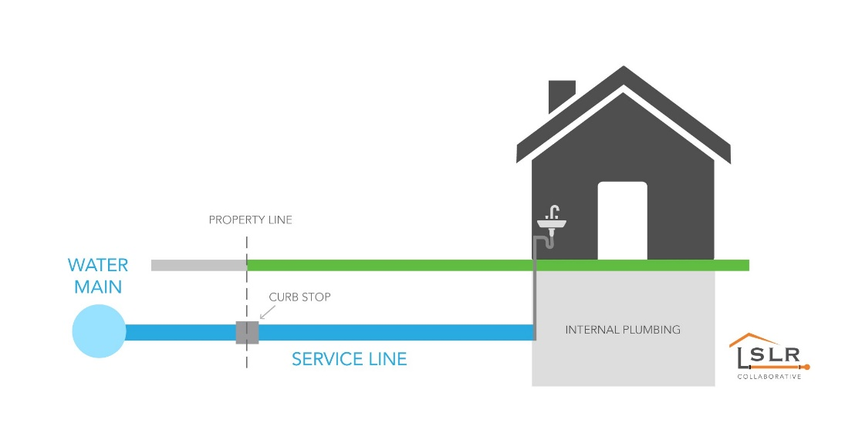

Individuals can find information on service line material information on addresses located in Minnesota at: [Minnesota Service Line Material Tool (umn.edu)](https://maps.umn.edu/LSL/) (https://maps.umn.edu/LSL/)

## Identifying service line material

To help determine the material of your service line, please contact us at **218-302-5996 or email at jlammers@cityofvergas.com.** EPA has developed an online step-by-step guide to help people identify lead pipes in their homes called Protect Your Tap: A Quick Check for Lead. It is available at: <https://www.epa.gov/ground-water-and-drinking-water/protect-your-tap-quick-check-lead>.

## Health effects of lead

*Exposure to lead in drinking water can cause serious health effects in all age groups. Infants and children can have decreases in IQ and attention span. Lead exposure can lead to new learning and behavior problems or worsen existing learning and behavior problems. The children of women who are exposed to*

*lead before or during pregnancy can have increased risk of these negative health effects. Adults can have increased risks of heart disease, high blood pressure, and kidney, or nervous system problems.*

## Steps you can take to reduce lead in drinking water.

Below are recommended actions that you may take, separately or in combination, if you are concerned about lead in your drinking water. The list also includes links where you may find more information and is not intended to be a complete list or to imply that all actions equally reduce lead in drinking water.

**Use a filter**. Using a filter can reduce lead in drinking water. If you use a filter, it should be certified to remove lead. Read any directions provided with the filter to learn how to properly install, maintain, and use your cartridge and when to replace it. Using the cartridge after it has expired can make it less effective at removing lead. Do not run hot water through the filter. For more information on facts and advice on home water filtration systems, see EPA’s <https://www.epa.gov/water-research/consumer-tool-identifying-point-use-and-pitcher-filters-certified-reduce-lead>.

**Clean your aerator.** Regularly clean your faucet’s screen (also known as an aerator). Sediment, debris, and lead particles can collect in your aerator. If lead particles are caught in the aerator, lead can get into your water.

**Use cold water**. Do not use hot water from the tap for drinking, cooking, or making baby formula as lead dissolves more easily into hot water. Boiling water does not remove lead from water.

**Run your water.** The more time water has been sitting in pipes providing water to your home, the more lead it may contain. Before drinking, flush your home’s pipes by running the tap, taking a shower, doing laundry, or doing a load of dishes. The amount of time to run the water will depend on whether your home has a lead service line or not, as well as the length and diameter of the service line and the amount of plumbing in your home. Residents may contact us at **218-302-5996 or email at jlammers@cityofvergas.com** for recommendations about flushing times in their community.

**Learn what your service line material is.** Contact us, your water system, at **218-302-5996 or email at jlammers@cityofvergas.com** or a licensed plumber to determine if the pipe that connects your home to the water main (called a service line) is made from lead, galvanized, or other materials. Alternatively, you can also follow this link: https://www.epa.gov/ground-water-and-drinking-water/protect-your-tap-quick-check-lead-0 to find lead pipes in your home.

**Learn about construction in your neighborhood.** Contact us, your water system, at **218-302-5996 or email at jlammers@cityofvergas.com** to find out about any construction or maintenance work that could disturb your service line. Construction may cause more lead to be released from a lead service line or galvanized service line if present.

**Have your water tested.** Please contact a [Minnesota Department of Health accredited laboratory](https://eldo.web.health.state.mn.us/public/accreditedlabs/labsearch.seam) (https://eldo.web.health.state.mn.us/public/accreditedlabs/labsearch.seam) to purchase a sample container and instructions on how to submit a sample. Note, a water sample may not adequately capture or represent all sources of lead that may be present**.** For information on sources of lead that include service lines and interior plumbing, please visit <https://www.epa.gov/ground-water-and-drinking-water/basic-information-about-lead-drinking-water#getinto>

## Understand Blood Lead Testing

In Minnesota, elevated blood lead levels are most associated with lead exposure from lead paint and dust. Water is rarely the cause of elevated blood lead levels. If you have concerns about childhood lead exposure, check with your family doctor, pediatrician, or health care provider to determine if a blood test for lead is recommended. State, city, or county departments of health can also provide information about health effects of lead and how you can have your child's blood tested for lead. The Centers for Disease Control and Prevention (CDC) recommends that public health actions be initiated when the level of lead in a child’s blood is 3.5 micrograms per deciliter (μg/dL) or more. For more information and links to CDC’s website, please visit [https://www.epa.gov/ground-water-and-drinking-water/basic-information-about-lead-drinking-water](https://gcc02.safelinks.protection.outlook.com/?url=https%3A%2F%2Fwww.epa.gov%2Fground-water-and-drinking-water%2Fbasic-information-about-lead-drinking-water&data=05%7C02%7CHaripriya.Naidu%40state.mn.us%7C85debdcf617b4d5be3ba08dccdc89270%7Ceb14b04624c445198f26b89c2159828c%7C0%7C0%7C638611508529267170%7CUnknown%7CTWFpbGZsb3d8eyJWIjoiMC4wLjAwMDAiLCJQIjoiV2luMzIiLCJBTiI6Ik1haWwiLCJXVCI6Mn0%3D%7C0%7C%7C%7C&sdata=KB%2Baz3CxSpJAX5SDoaus8KsTAzhorbP%2FrF85IYd4Il0%3D&reserved=0). MDH also has [Lead Information for Families(https://www.health.state.mn.us/communities/environment/lead/families.html)](https://www.health.state.mn.us/communities/environment/lead/families.html).

To find out about what we are doing to replace lead service lines, please contact us at **218-302-5996 or email at jlammers@cityofvergas.com.**

**For information about potential financing solutions** to assist property owners with replacement of lead service lines, please contact us at **218-302-5996 or email at jlammers@cityofvergas.com**

**For additional information on the Lead Service Line Replacement Program, please visit:**

[Lead Service Line Replacement Program Facts - MN Dept. of Health (state.mn.us)](https://www.health.state.mn.us/communities/environment/water/lslrprogram.html)

(<https://www.health.state.mn.us/communities/environment/water/lslrprogram.html>)

**For more information about lead in drinking water visit the Minnesota Department of Health webpage** **at:**<https://www.health.state.mn.us/communities/environment/water/contaminants/lead.html>