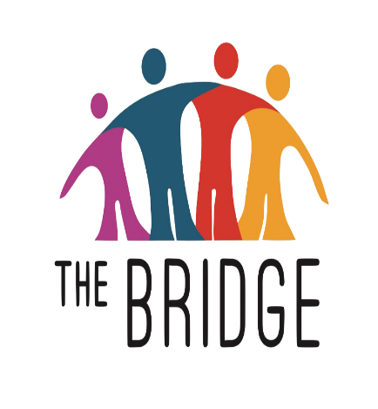
2021 VERGAS SCHEDULE
St. John’s Lutheran Church
410 E. Scharf Ave.
10 AM – NOON
Oct. 6
Nov. 3
Dec. 8
Access most current information here: www.thebridgepantry.org

