 NEWSLETTER

**Thank you to everyone who has had their electronic meter installed!**

On Sept. 8th, Council approved

a $25 fee to read non-electronic meters beginning Jan. 1, 2021.

If you have not had an electronic meter installed, please call the city office today to schedule an appointment.

218-342-2091

*********************************************

**WEAR A 2020 HAIRYMAN SHIRT OR MASK AND RECEIVE 10% OFF**

**YOUR LIQUOR STORE PURCHASE**

**GOOD THRU OCTOBER 31, 2020**





**General Election**

**Nov. 3, 2020**

7 AM- 8 PM

-Local Offices-

Mayor (2 yr. term)

Incumbent - Dean Haarstick

Julie Bruhn

2 Council Members

(4 yr. term)

Incumbent - Paul Pinke

Incumbent - Natalie Fischer

Bruce Albright

Austin Tegtmeier

VERGAS EVENT CENTER

140 W. Linden Street

Last day to pre-registration will be

October 13th, 2020.

**Voter Registration and**

**MN Absentee Ballot Applications**

**available at the City Office or at**

**ottertailcountymn.us/department/elections**



**CITY MEETINGS**

**ALL OF THESE MEETINGS may BE**

**VITUAL MEETINGS OR CANCELLED**

**check THE WEB PAGE**

[**WWW.cityofvergas.com**](http://WWW.cityofvergas.com)

**Vergas EDA:**

Wednesday – November 4, 2020

9:00 a.m.  ZOOM MEETING

(*1st* Wednesday of the month)

**Vergas Planning Commission:**

Monday- October. 26, 2020

6:00 p.m. ZOOM MEETING

(4th Monday of the month)

**Vergas City Council Meeting:**

Tuesday- October 13, 2020

6:30 p.m.

(2nd TUESDAY of the month)

**(If you would like to be on the agenda please have information to City Clerk by the Wednesday before meeting)**

**Vergas Event Center Advisory Board:**

Wednesday-November 10 , 2020

6:30 p.m.

Vergas Event Center

(2nd Wednesday of the month)

**Vergas Park Advisory Board:**

Thursday-October 22, 2020

1:00 p.m.

Vergas Event Center

(4th Thursday of the month)

*****************************

**Changes in our meetings**

**and Zoom details**

**to be posted on the**

**City of Vergas website**

***www.cityofvergas.com***

PHONE 218-342-2091

MON-THU 9am- 8:55 pm

FRI-SAT 9am-9:55 pm

SUN 11am – 5pm





2020 Vergas Hairyman Event is a

*Fundraiser for the Vergas Long Lake Trail*

“Social Distance like the H*airyman*”

Shop at the Vergas Liquor Store or Elm Street Boutique to buy

2020 Hairyman Shirt and/or Mask

**Take a walk on the trail... Enjoy the outdoors!**



LION’S HALLOWEEN

Sat. October 31 / 4 to 6 p.m.

Trunk or Treat

By Event Center

Looking for end of year donations?

Remember the projects close to home:

**Vergas Event Center remodel project**

**Vergas Trail**

**Vergas EDA**

Send donation to:

West Central Initiative

PO Box 318

Fergus Falls, MN 56538-0318

(Location: 1000 Western Avenue)

or use your credit or debit card at cityofvergas.com website

or drop off donation at

the Vergas City Office.

**Please designate which project you would like to donate toward**

**when submitting payment.**

To all who suppored the Vergas Long Lake Trail Project over the last 8 years… 

For buying raffle tickets, attending fundraisers, volunteering for events & projects.

Because of all YOU have done, we have a wonderful addition to our community for countless people to enjoy for generatons.

LET THE FUN CONTINUE…..

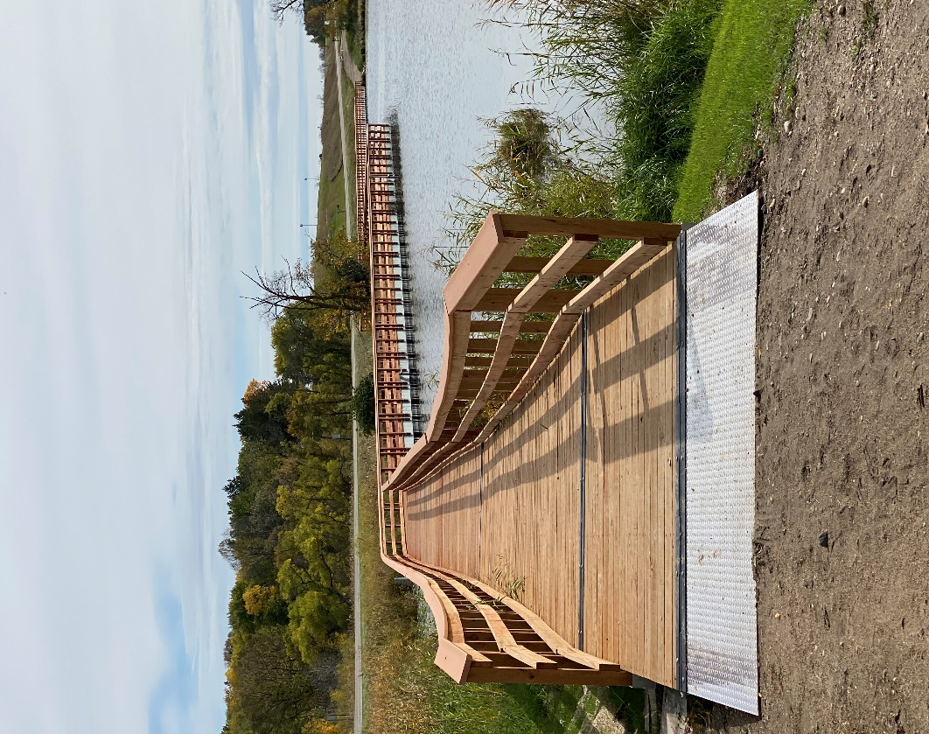

PUBLIC HEARING NOTICE

Notice is hereby given that the Vergas City Planning Commission will conduct a Public Hearing regarding a vacation of East Railway Avenue, Nesbitt Avenue, and Lover’s Lane.

All interested parties are invited to attend and will be given the opportunity to ask questions and to provide public input and/or comments. If you are unable to attend the hearing, you are invited to submit your comments in writing to the City Clerk-Treasurer prior to the scheduled hearing. Written comments or questions will be addressed at the hearing and a written response will be provided by the City. Non-English-speaking residents and other persons with special needs who plan to attend the hearing are asked to contact City Hall (218) 342-2091 prior to the hearing so that arrangements can be made to address any special requirements.

The Public Hearing on this request will be held by the Vergas Planning Commission at 6:30 p.m. on Monday, October 26, 2020.

Attend the meeting via Zoom, **City of Vergas website**

[***www.cityofvergas.com***](http://www.cityofvergas.com) ***– thru virtual meeting tab.***

Julie Lammers

City Clerk-Treasurer

**To join via ZOOM, go to City of Vergas website: *www.cityofvergas.com***

**FLU VACCINE CLINIC INFO**

[**OTC Public Health**](https://ottertailcountymn.us/department/public-health/)**-Phone:** 218-998-8320 or TOLL FREE 888-349-2581

ottertailcountymn.us/content-page/flu-vaccine