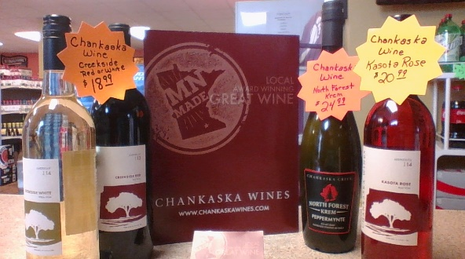

City Meetings
• • •
City Council Meetings
Tuesday May 10, 2016
Tuesday June 7, 2016
6:30 p.m.
Vergas Event Center
(If you would like to be on the agenda please have information to City Clerk by the Wednesday before meeting)

Planning Commission
Wednesday May 18, 2016
5:30 p.m.
Vergas Event Center
(If you would like to be on the agenda please have information to City Clerk by the Wednesday before meeting)
Vergas EDA
1st Monday of the month
12:00 p.m.
Billy’s Corner Bar
Event Center Advisory Board
4th Tuesday of the month
5:15 p.m.
Vergas Event Center
Changes in our meetings to be posted on the City of Vergas website: www.cityofvergas.com
Hazardous Waste Collection Day
Friday July 15, 2016 from 10 a.m. to 2 p.m. Volunteers are needed please contact the City Office (342-2091) if you are interested
When: Every Tuesday & Friday From 9:00am- 1:00pm
Where: at the Lion’s Shelter behind the Vergas Event Center

Check out our New Wine from Chankaska Winery at the Vergas Municipal Liquor Store
Open-9-9 Mon-Thurs
9-10 Fri & Sat
Annual Pet Vaccination Clinic
Will be held on Thursday May 12, 2016
from 4:30pm to 6:30pm
City Licenses are required for all dogs living or visiting the City of Vergas.
Licenses ($5 for spayed or neutered and $8 for unspayed or unneutered) will be availablne for purchase at the clinic or at the City office.
City of Vergas

Vergas Community Members
Vergas is looking for Grand Marshal(s) nominations for the 2016 Looney Daze parade. Please email an nominations or return this nomination form to:
Looney Daze Parade Chair
440 S Pelican Ave
Vergas MN 56587
Email: Lhoffmann2@hotmail.com
Or drop off at Liquor Store

Name(s):________________________
Reason for Nomination (Must have some connection/affiliation to the city of Vergas….please explain why you think this nomination would be a good fit for the Grand Marshall):
_______________________________________________________________________________________________________________________________________________________________________________________________________________________________________________________________________________________________________________________________________________________________________________________________________________________________________________________________ Nominations accepted until June 13th.
Voting at Vergas State Bank June 20th through July 15th.
Volunteers Needed For
Looney Daze
If you would like to help, please contact
Renee Sonnenberg at 218-841-0712
Or reneejsonnenberg@hotmail.com

Mark your Calendars
Prairie Fire Children’s Theatre
“Peter Pan”
July 1st @ 7 pm
July 2nd @ 1:30 pm
To Register:
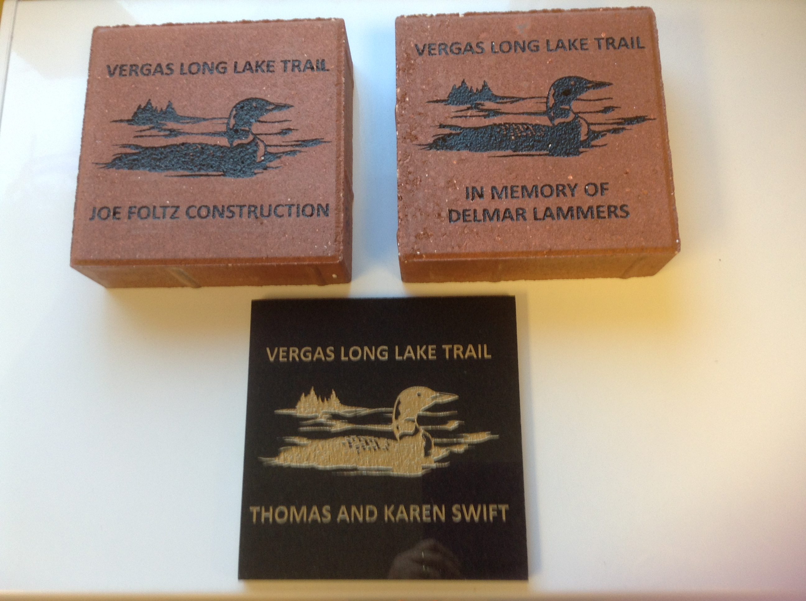 ISD#23-Community Education 305 North Lake Street, Frazee, MN 56544 Phone: (218) 334-3181 Option 3
www.frazee.k12.mn.us/Community-Education/youth-enrichment

Hazardous Waste day
Friday July 15th

