# Calendar of Events

**Community Health Fair**

9:00am to 5:00pm on April 5th, 2014

Located at the Vergas Event Center.

# Maple Syrup Fest

City of Vergas

|  |  |
| --- | --- |
|  |  |

April 12th, 2014 marks the 14th annual Maple Syrup Fest.

Sap 5k run—Registration forms available on the City of Vergas website and the City Office.

www.cityofvergas.com

**Vergas Liquor Store**

Beer Tasting on March 13th, 2014

Don’t forget to “LIKE” us on Facebook and see all of our sales!



# Ordinance Review

**92.20 INOPERABLE MOTOR VEHICLES.**

(A) It shall be unlawful to keep, park, store or abandon any motor vehicle which is not in operating condition, partially dismantled, used for repair of parts or as a source of repair or replacement parts for other vehicles, kept for scrapping, dismantling or salvage of any kind, or which is not properly licensed for operation with the state, pursuant to M.S.  168B.011, Subd. 3, as it may be amended from time to time.

(B) This section does not apply to a motor vehicle enclosed in a building and/or kept out of view from any street, road or alley, and which does not foster complaint from a resident of the city. A privacy fence is permissible.

(C) Any motor vehicles described in this section constitute a hazard to the health and welfare of the residents of the community in that such vehicles can harbor noxious diseases, furnish a shelter and breeding place for vermin and present physical danger to the safety and well-being of children and citizens; and vehicles containing fluids which, if released into the environment, can and do cause significant health risks to the community.

Penalty, see  92.99

# City Meetings

• • •

**City Council Meetings**

2nd Monday of the Month

6:30 p.m.

Vergas Event Center

(If you would like to be on the agenda please have information to City Clerk by the Wednesday before meeting)

**Emergency Planning**

3rd Wednesday of the month

8:00 a.m.

Vergas Event Center

**Event Center Advisory Board**

4th Tuesday of the month

5:15 p.m.

Vergas Event Center

(Changes in our meetings to be posted on the City of Vergas website: www.cityofvergas.com)

**Frozen Service Lines**

**Frequently Asked Questions**

***Frequently Asked Questions:***

**Q. I think my service line is frozen.   
What should I do?**

A. Contact a contractor to thaw the service line.

**Q. Does the City thaw service lines?**

A. No, but it is important to let the City know that your service line is frozen.

**Q. Does the City give a credit or reimburse for the water if we let our facets run?**

A. No, the City does not give a discount for the

water use. All water going through the water

meter will be billed. The City will be discussing this at our March Council meeting on March 10.

**Q. How much does it cost to thaw a service line?**

A. The price varies by contractor. The **minimum**

fees are running around $175.

**Q. How much does it cost to Let It Run!?**

A. It will cost homeowners around $1 a day to Let

It Run! It is the best insurance policy available.

**Q. How can I tell if my water line is freezing?**

A. Some people have been giving no warning at

all. Some people see a drop in water pressure

before the line freezes.

**Q. If my neighbor freezes, should I run my water?**

A. The City strongly encourages you to let your water run if your neighbor or someone close by you freezes. The lack of movement can cause problems for neighborhoods.

***TO PREVENT SERVICE LINES FROM   
FREEZING THE WATER MUST BE RUNNING.*MOVEMENT IS AN EFFECTIVE WAY   
TO HELP PREVENT FREEZING.**

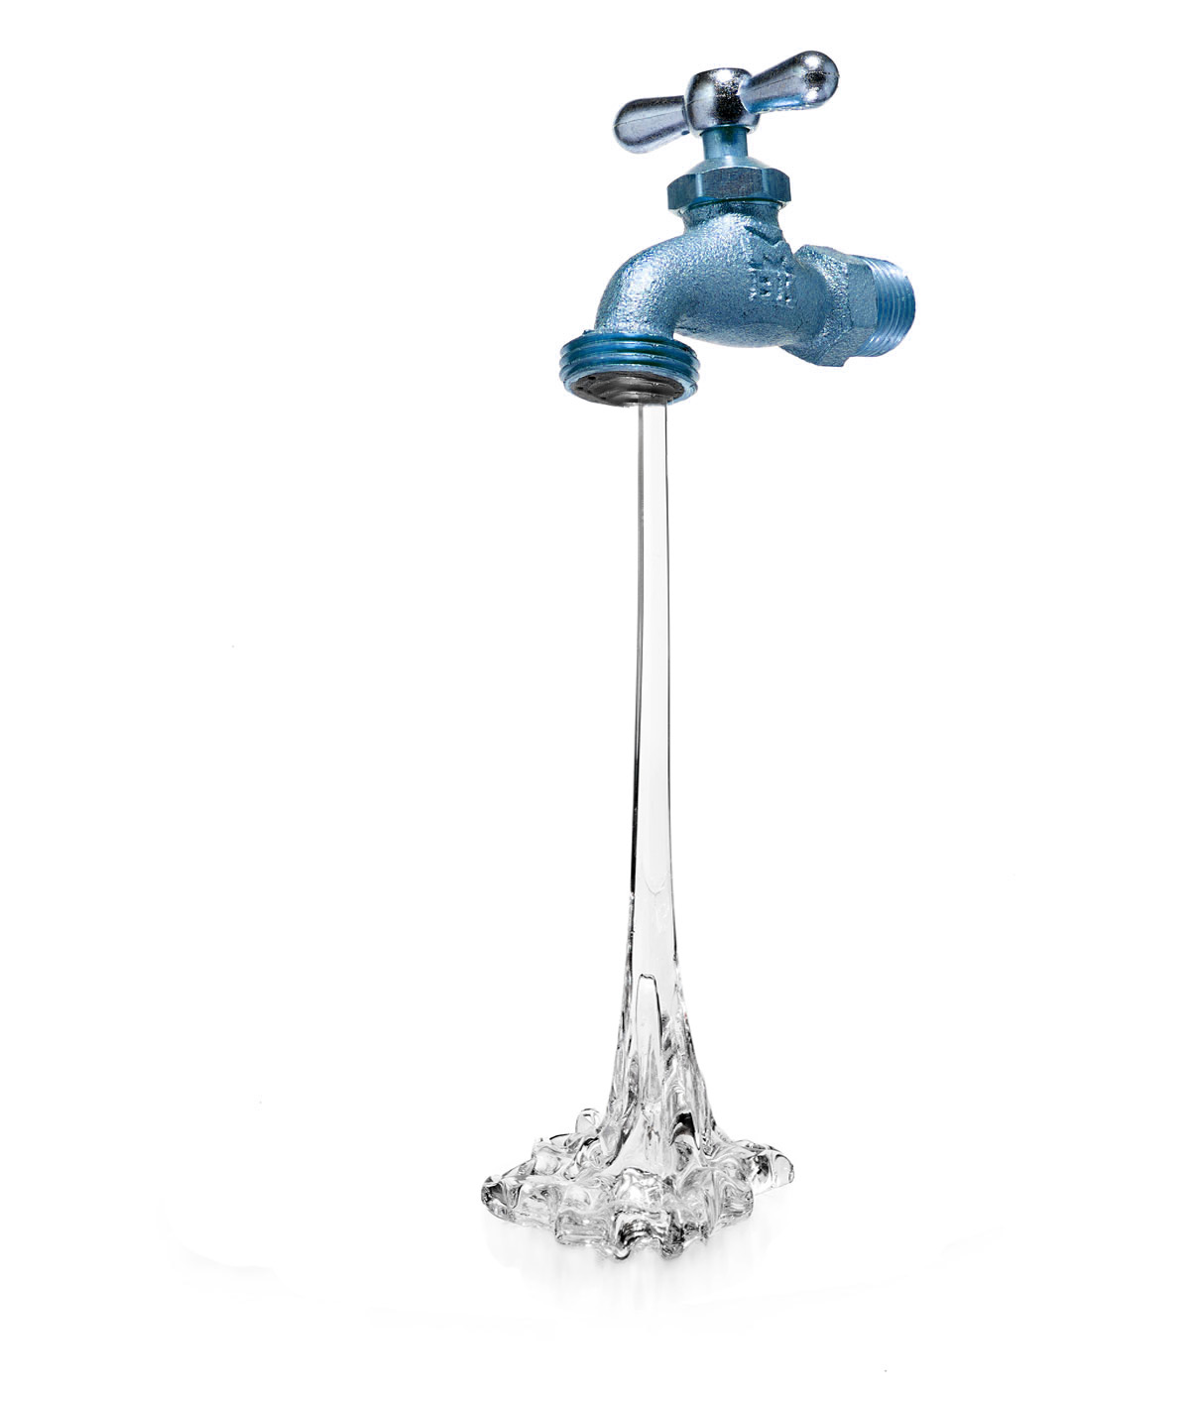

**PLEASE NOTE!  
Running water may increase your water bill**

**If your neighbor’s pipes are frozen...**

**You (yours?) could be next!**

**REDUCE THE RISK OF FROZEN PIPES**

**Leave a cold water tap running at a   
steady stream of about 1/4 in.**

* Leave the cupboard doors open under your kitchen and bathroom
* Do not turn your furnace below 55° F
* Shut off and drain the pipes leading to outside faucets
* Wrap foam insulation around pipes most susceptible to freezing
* Seal air leaks in your home and garage
* If you are away, have someone check your home regularly