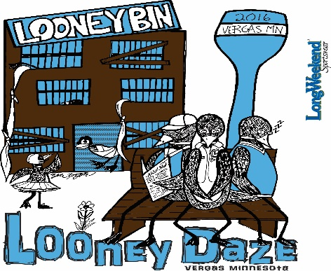

Pre-Registration is $20 by July 30th * If registered by August, 12th its $25 * Day of race registration is $30*   
Registration from 7:00 a.m. to 7:30 a.m.   
 Race at 8:00 a.m.

**Welcome to the   
Looney Bin 51 Years**  
**5K Run  
Vergas, MN 56587**   
***August 13th, 2016***

This year’s Looney Daze is sponsoring a 5k Run/Walk. Registration includes an event T-Shirt. (***T-Shirts will not be guaranteed to runners that are not pre-registered***.) Pre-registration must be postmarked by July 30th, 2016. Race Day registration and check-in will be at Hanson’s Plumbing and Heating, 101 Railway Avenue, Vergas, MN 56587. Awards will be presented after the race at Hanson’s as well. (Available at Liquor Store after the Race- they will not be mailed.)

**Awards will be given for the following categories:**

Open Class medals for male/female 1st, 2nd & 3rd   
 13 & Under male/ female 1st, 2nd & 3rd 41-50 male/female 1st, 2nd & 3rd  
 14-20 male/female 1st, 2nd & 3rd 51-60 male/female 1st, 2nd & 3rd  
 21-30 male/female 1st, 2nd, & 3rd 60+ male/female 1st, 2nd & 3rd  
 31-40 male/female 1st, 2nd & 3rd

**SEND PRE-REGISTRATION FORM AND CHECKS TO:   
 Vergas City Clerk  
 P. O. Box 32  
 Vergas, MN 56587  
Make checks payable to: VERGAS COMMUNITY CLUB**

Last Name (please print) First Name Sex (M/F) Age

­­­­­­­­­­­­­­­­­­­­­­------------------------------------------------ ---------------------------------------------- -------------------- --------------

Street Address City State Zip

------------------------------------------------ --------------------------------- ------------------------- ----------------------

Email Address Phone T-Shirt Size

------------------------------------------------------------- ----------------------------------- ---------------------

T-Shirts will be given out on race day check-in, Pre-register to guarantee a t-shirt.

**WAIVER: I hereby absolve myself, my heirs, executors, and administrators, forever, any and all rights and claims I may accrue against Vergas Community Club, the City of Vergas, and other sponsors, race officials, of any and all injuries suffered by me while participating the 2016 Welcome to the Looney Bin 5k Run/Walk. I further certify that I am physically fit to run/walk in the contest for which I am entered on August 13th, 2016. I further grant full permission of this event and any organization conducting the event and/or agents authorized by them, to use any photographs, videotape, motion pictures, recordings, or any other record of the event for any purpose without compensation. If I am under 18 years of age, may parent or guardian has signed this waver.**

--------------------------------------------------------------------- -------------------------------- --------------------------------  
**Signature of participant or Guardian if under 18 Date Racer #**