Vergas Long Lake Trail
Fundraiser
Legacy Bricks
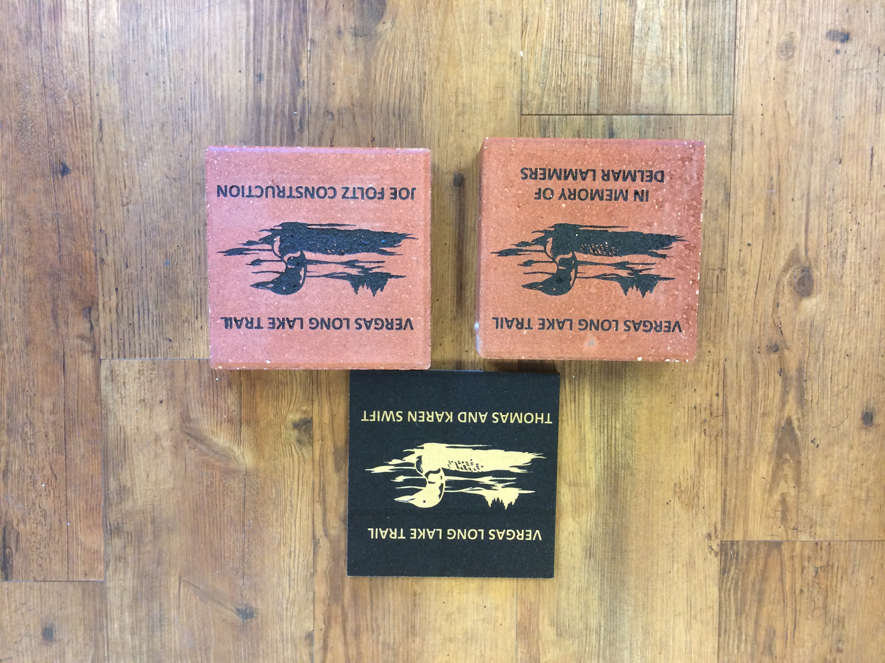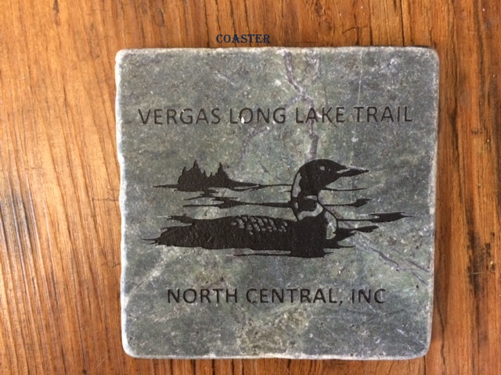

Vergas Long Lake Trail
Picture of Loon
Your name or engraving

I would like to make a donation by purchasing a plaque or brick.

8x8 Granite Plaques $500.00 each ______________ Thank you coaster included

8x8 Bricks $150.00 each _____________ Thank you coaster $10.00 ______

To receive a coaster you must provide an email address so we can let you know when they are available to be picked up. No coasters will be mailed.

Organization____________________ Contact Person __________________________

Mailing Address____________________City________________State____Zip____________

Phone # __________________ Email ____________________________________________

Please engrave the following on my plaque or brick:

Business name: ___________________________________________
Or
Family name: ____________________________________________
Or
In Honor of: ____________________________________________
Or
In Memory of: ___________________________________________

Make checks payable to: Vergas City Trail Fund and send with payment.
First order of bricks will be ordered on June 1, 2017
We thank you in advance for purchasing and helping us to connect the trails.
Please return this completed form with your payment to:
City of Vergas
PO Box 32
Vergas, MN 56587-0032

